**CS590BD Big Data Analytics and Applications**

**Lab-5 Assignment**

**By**

**Kommineni Siva Krishna**

**Summary:**

Building an on-line motion based game application using the existing open source android project, data processing and motion recognition apps provided.

Developing a game by enhancing existing features and matching them to the direction movements of the sensors.

**Implementation:**

The implementation part typically consisted of three parts. They are:

* Establishing the connection between the sensor tag movement and the open source game actions.
* Collection of the Data and later train, test to generate the sequence files
* Analyzing the collected data based on the actions and sensor movement and classifies the actions based on the classification and clustering algorithms.

First we implement the application using an open source android game called a simple Ball game.

We installed it on our local Eclipse ADT and the package structure is formed as shown below in the frame work.

There is an Accelerometer handler class in the application so that we can control and collect the acceleration data from the application by connection establishment with the sensor tag.

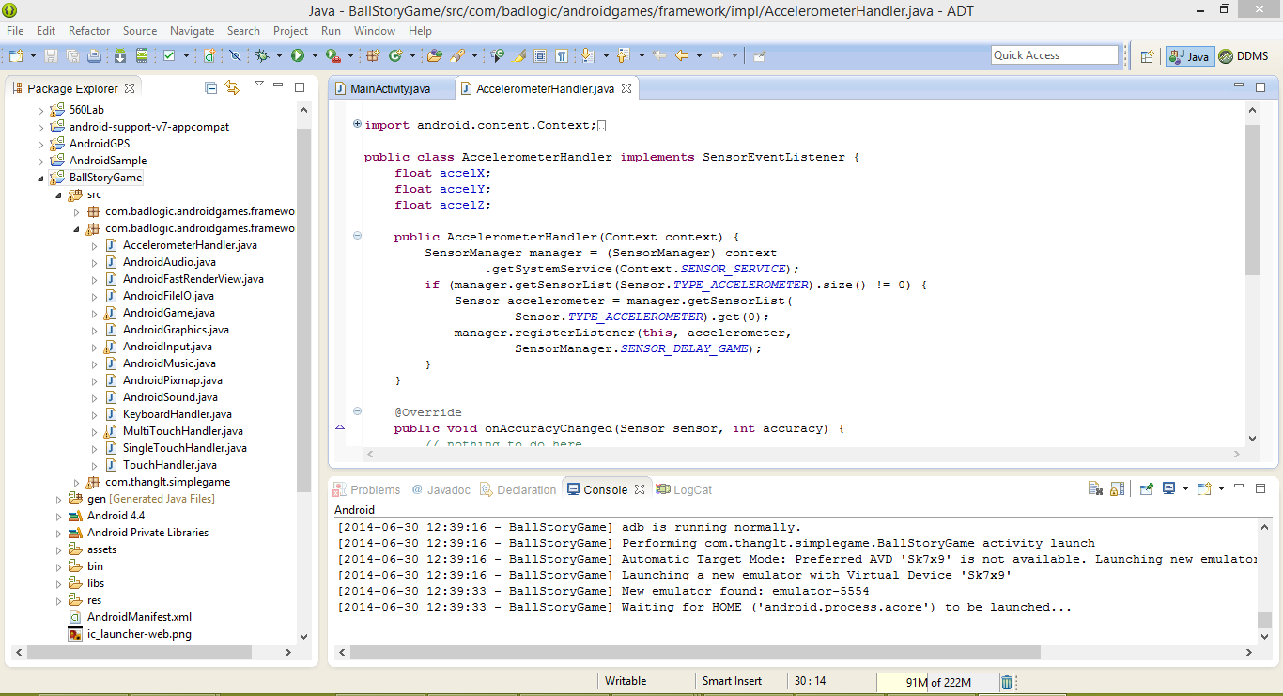

We have modified the existing open source project by adding the following classes to establish the connections and use the existing model of Data collection and motion recognition applications.

* ConnectionService.java
* TestGesture.java
* SensorTagData.java

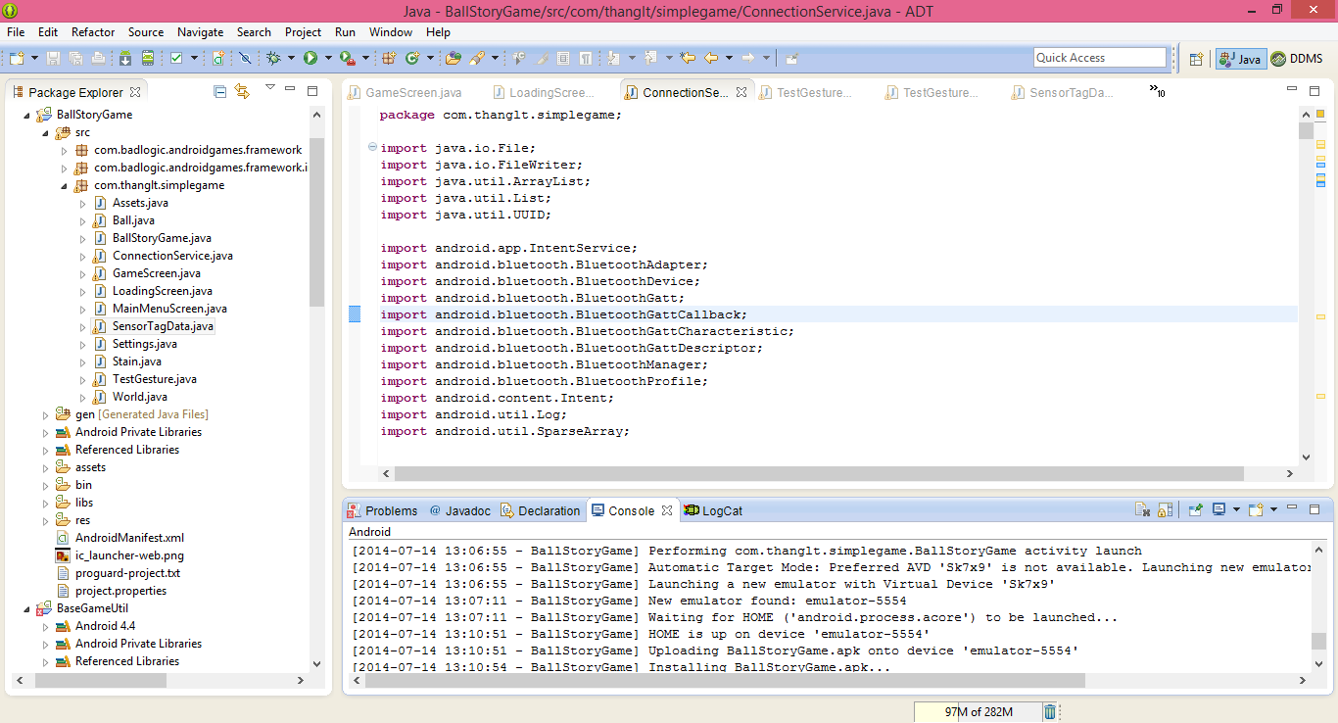

* All the classes consists of the Data Collection, Activity, Motion recognition applications for handling the open source project.
* To test the application we are running it on the emulator for performing the basic operations.
* We run it as an Android application so that it will be launched on the emulator.
* The screen below shows that the emulator is being launched successfully in the console.

Console shows the progress of the application in launching it on the emulator.

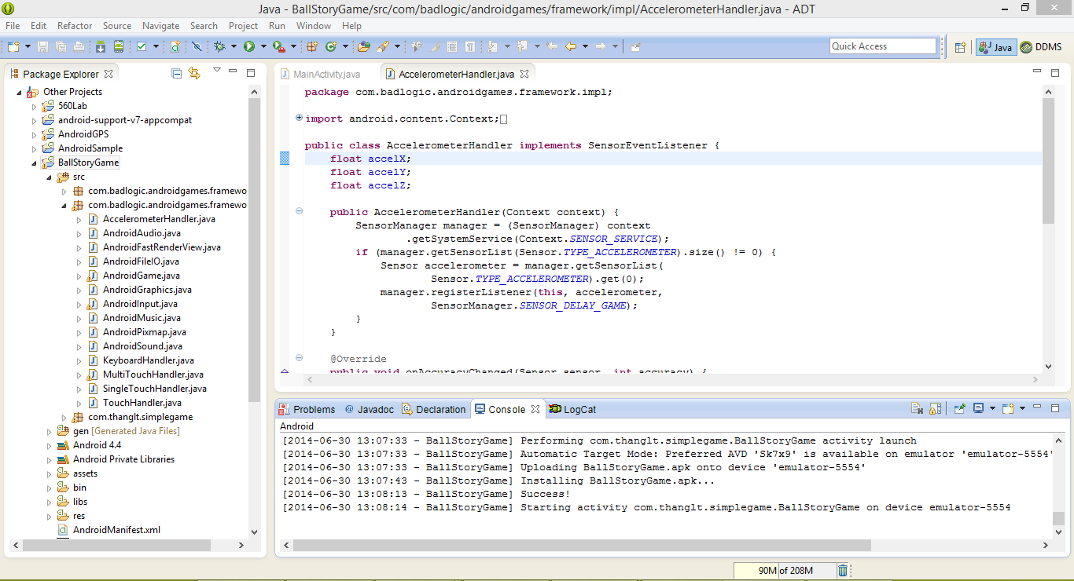

The below figures shows the sequence of basic operations in the open source game.

First it shows the app named Sample Game in the UI.

After launching it by clicking on the icon we get the emulator populated with the game as below.

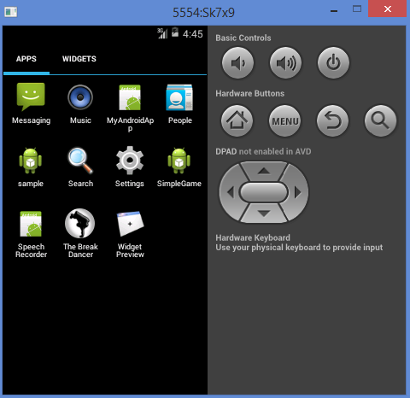 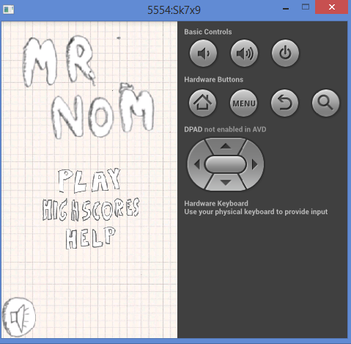

Later when we click on the play it asks to get ready to play the game. After touching the screen it starts moving the ball in all the directions based on the arrow key controls shown in the screen below. The ball moves in all the directions, While this movements we should collect the accelerometer readings for the movement of the ball.

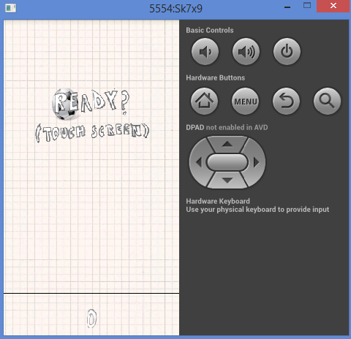

The ball moves in all the four directions left ,right,up,down.

We established a connection between this movements based on the sensor tag movements such that we can play the game usingthe sensor tag.

The arrows in the bottom of the screen is helpfiul for the direction change in the space. The ball changes its direction by every 90 degrees when we click on the arrow.

This direction and motion change is now controlled by the motion detection applications.

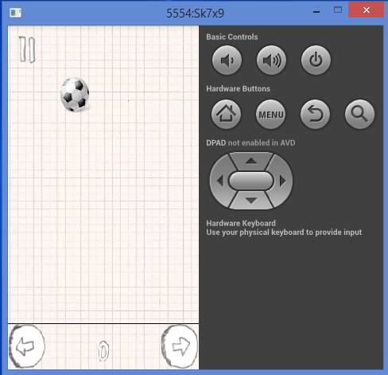

We trained a set of data using some training samples and generated sequence files for all the directions and movements in the game.

Thus we can have the control over the game using the sensor tag movements.

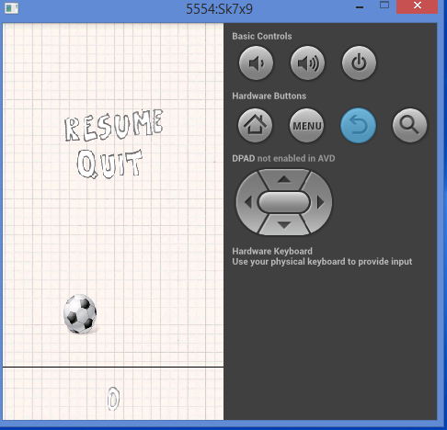

We collect the data from these applications and then cluster, analyze it and compare them by using the machine learning algorithms to form grouping of the data based on the actions, direction of movements using the applications provided.